**Part I: Summary of Findings**

**Reasons for establishing the need for a proposed design:**

Recent studies provide evidence suggesting that metabolic characteristics of cancer cells are not passive responses, but result from oncogenic metabolic reprogramming necessary to sustain cancerous growth.1 As a result, the metabolic characteristics of cancer cells are distinct from those of normal cells. However, there is a lack of comprehensive knowledge pertaining to metabolic pathways and their associated kinetics.2 Understanding the breadth and functional implications of oncogene-modulated metabolism demands enables therapeutic strategies targeting cancer metabolism to be developed. Recent studies have also demonstrated that cancer cells build up resistance to current cancer therapeutics, reducing the efficacy of various treatments that also accrue various side effects.3 There is a need to discover therapeutic methods that 1) treat cancer, 2) overcome cancer cell resistance, and 3) minimize treatment-induced side effects. It has been established that targeting metabolic enzymes improves the efficacy of cancer therapy and can overcome therapeutic resistance developed by cancer cells.4 Therefore genome-scale cancer metabolism modeling is a valuable tool that can be further optimized and developed for practical applications in combatting cancer.

**The need for a proposed design and its origin:**

As a result of recent advances in omics measurement technologies, altered metabolism can be characterized genome-wide.2 Computational modeling is needed to comprehensively understand the state of the network under varying conditions which allows us to potentially uncover new drug targets.

**Potential users and beneficiaries:**

Our model will be used by researchers in the lab at pharmaceutical companies. It will allow them to pre-screen potential drug treatments and observe the effects each drug has on a particular enzymatic mutation. This solution will be beneficial compared to the existing method of cancer drug development, because it will be a better indicator of what will be an effective therapy before it is tested in vitro and in vivo. Efficiencies in such a large scale operation could translate into cost effectiveness for big pharma companies, whether these savings can be translated into lower price points for patients is a matter of healthcare and policy, but increasing the efficacy of drug discovery will speed up the availability of novel cancer drugs which will in turn give cancer patients a more favorable prognosis. Lastly, the experimental verification of our model has the potential to increase the validity of metabolic modeling projects, and open doors for their use universally by researchers and in pharma.

**Current state of technology and room for improvement:**

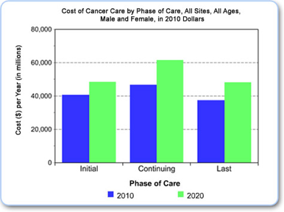 Currently, engineering and biological principles are being used by treating cells like black boxes.2 From here fluxes are being measured through the uptake of substrates and secretion of biomass or other products. This is because in metabolism raw materials that enter the cell are converted into other materials which can create byproducts that can be measured. This allows scientists to better understand the kinetics of cancer cell metabolism. As Dr. Brunk mentioned, metabolites can be tagged and then followed through the pathways in order to determine fluxes. However, using this approach neglects understanding the overall picture of cell metabolism. Modeling allows us to view the cell systematically and visualize the connections between pathways. Many researchers are only looking at isolated enzymes and targeting them without looking into other pathways that can be more readily inhibited.1

**Figure 1**: Summary of the total cost of cancer in 2010 and the projected costs in 2020.5

**REFERENCES:**  [1] Ward+, *Cancer Cell* 21:297-308, 2012. [2]  Yizhak+, *Mol Syst Biol.* 11:817-34, 2015. [3] Zhao+, *Cell Death Dis.* 4:e532, 2013. [4] Diaz+, *Nature* 486:537-40, 2012. [5] Mariatto+, *J Natl Cancer Inst.* 103(2):117-28, 2011.